Sohal Patel

Week 4 (Entity Relationship Modeling)

21. Regular ERD

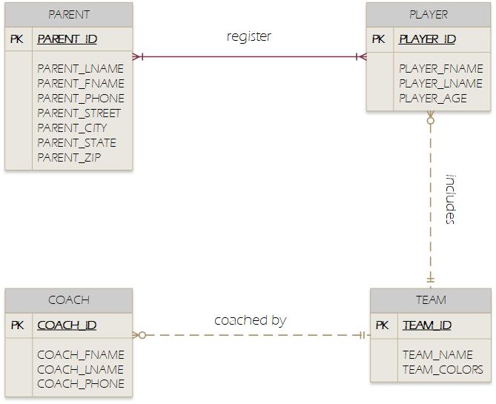

ERD with Foreign key.

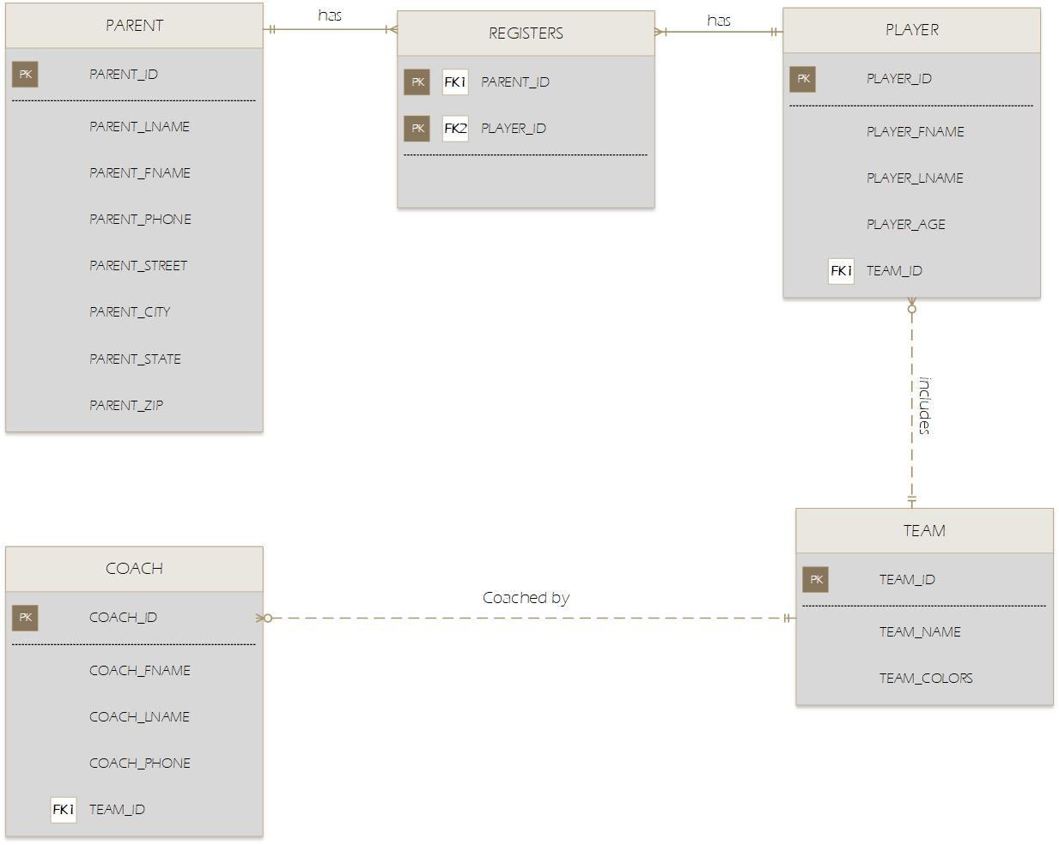

1. ERD for a medical clinic. The attributes with the Private keys are not necessary but just to show how it connects if it had attributes.

